Amazon Web Services

**Webserver**

* A Web server is a program that uses HTTP (Hypertext Transfer Protocol) to serve the files that from Web pages to users, in response to their request.

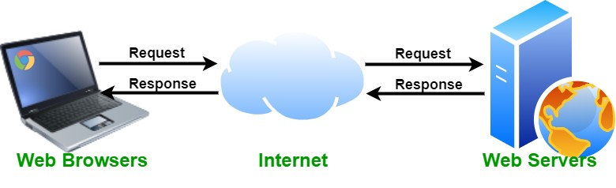

## Example of Webservers

* Apache HTTP Server
* Internet Information Services (IIS)
* NGINX
* HTTPD by Apache
* **HTTPD**: HTTP Daemon is a software program that runs in the background as a web server. It waits for the incoming server requests. The daemon answers the request and serves the hypertext and multimedia documents over the Internet using HTTP.

# Linux Webserver

* We will install HTTPD by Apache & it will be the Two Step Process
* Step 1: Update the YUM Repository
* Step 2: Install Web Package

## Create Linux EC2 Machine

* Connect the Linux EC2 Machine

## Switch User to root

sudo su

## Update the YUM Repository

yum update -y

## Install Web Package

yum install httpd -y

## Move to the html Directory

cd /var/www/html

## Create web Page

echo “Amazon Web Services” > index.html

## Start web package

service httpd start chkconfig httpd on

* Now, Our Linux machine is webserver.
* Copy the Public IP & paste in Web Browser

Network & Security

Security Group

* Select our Security group
* Edit Inbound Rules
* Click on Add Rule.
* Change type to HTTP & Source as Anywhere IPV4
* Click on Save rules
* Now Refresh the Web browser
* **Repository:** A Linux repository is a storage location from which your system retrieves and installs OS updates and applications.
* We need to install web package, it is called web server. Package is nothing but software.
* **YUM Repository**: YUM Repositories are warehouses of Linux software. Sometimes the software we want to install is not available in Linux OS default. In such situations, we can use YUM Repositories. We can

install new software on Linux with “yum install

packagename" command from console.